**AI : TASK 3**

(Knowledge Representation : Semantic Net & Frame**)**

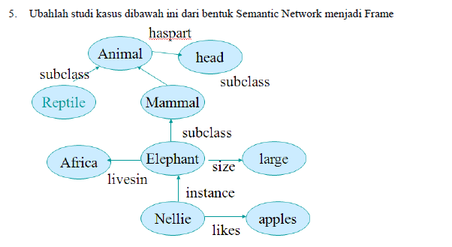

Jawaban :

* frame

|  |  |
| --- | --- |
| Animal | |
| Has | head |

|  |  |
| --- | --- |
| Nellie | |
| likes | Apples |

is_a

Is_a

|  |
| --- |
| mammal |

|  |  |
| --- | --- |
| Elephant | |
| size | Large |
| Lives in |  |

|  |
| --- |
| reptile |

|  |
| --- |
| Africa |

Lives_in

ako

is_a

* prolog’s script

|  |
| --- |
| **attribute(animal,has,head).**  **attribute(elephant,size,large).**  **attribute(elephant,lives_in,africa).**  **attribute(nellie,likes,apples).**  **is_a(mammal,animal).**  **is_a(reptile,animal).**  **is_a(elephant,mammal).**  **ako(nellie,elephant).**  **subclass(Class1,Class2):-is_a(Class1,Class2).**  **subclass(Class1,Class2):-is_a(Class1,Class3),subclass(Class3,Class2).**  **aninstance(Obj,Class):-ako(Obj,Class).**  **aninstance(Obj,Class):-ako(Obj,Class1),subclass(Class1,Class).**  **value(Obj,Property,Value) :-attribute(Obj,Property,Value).**  **value(Obj,Property,Value) :-aninstance(Obj,Class).**  **attribute(Class,Property,Value).** |

* Capture

Subclass :

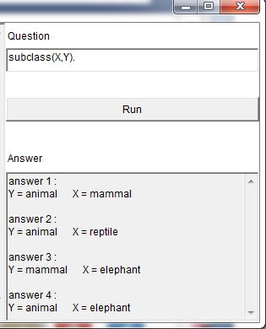

Instance :

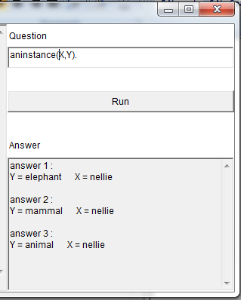

Attribute :

